- Formular of pointing error model of telescope mount(7 parameters):
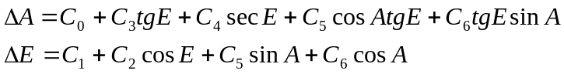
Where, 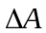、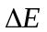 are star residuals of azimuth and elevation,A、E are star azimuth and elevation.
- Data used for calculating the mount coefficients:
- The file name is “data_for_calculation_of_the_mount_coefficients.dat”.
- the format of data:
the first column is the star azimuth of residuals,the unit is arcsecond;
the second column is the star elevation of residuals, the unit is arcsecond;
the third column is the star azimuth, the unit is degree;
the forth column is the star elevation, the unit is degree.
- The results of the mount coefficients calculated by our program:
C0 = -0.726806
C1 = 14.381022
C2 =-29.109666
C3 = 7.002453
C4 =-42.348260
C5 = -1.780741
C6 = -2.046496

